Hayden Wood

**Image Classification with SVM and CIFAR-10 Dataset**

**Understanding of the SVM Algorithm**

Primarily employed in group data sorting, Support Vector Machines (SVM) are supervised learning models. SVM is all about figuring out the best way to divide data points into groups in a vast area. It makes the space between the hyperplane and the closest data points from each class, called support vectors, as big as possible. SVM is particularly effective for linear classification but can also handle non-linear data using kernel functions.

In image classification, SVM is advantageous due to its ability to manage high-dimensional feature spaces, which is typical in image data. The CIFAR-10 dataset, consisting of 60,000 32x32 color images in 10 different classes, provides a robust environment for applying SVM for classifying images based on their features.

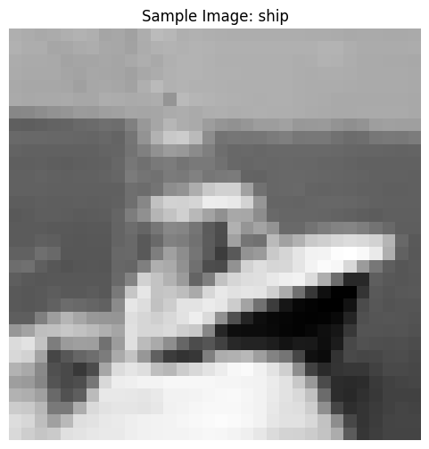

**Data Preparation Steps:**

Data preparation is crucial for practical model training. In this lab, the following steps were undertaken:

* Loading the CIFAR-10 Dataset: The dataset was imported and split into training and testing sets.
* Normalization: The pixel values of images were scaled to a range of [0, 1] to improve the convergence of the SVM model.
* Reshaping Data: Each 32x32 image was reshaped into a 1D array of 3072 features (32 * 32 * 3) to feed into the SVM model.

**Model Training and Evaluation Process:**

The SVM model was trained using the included training dataset. Key steps included:

* Defining the Model: The SVM model was created with a linear kernel, which assumes a linear relationship in the data.
* Fitting the Model: The model was trained on the reshaped and normalized training data.
* Evaluation: The model's performance was assessed using the testing dataset, where accuracy and confusion matrices were computed to gauge how well the model classified the images.

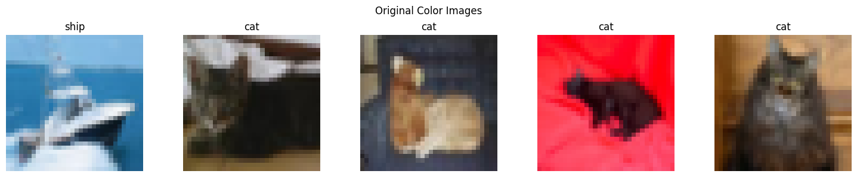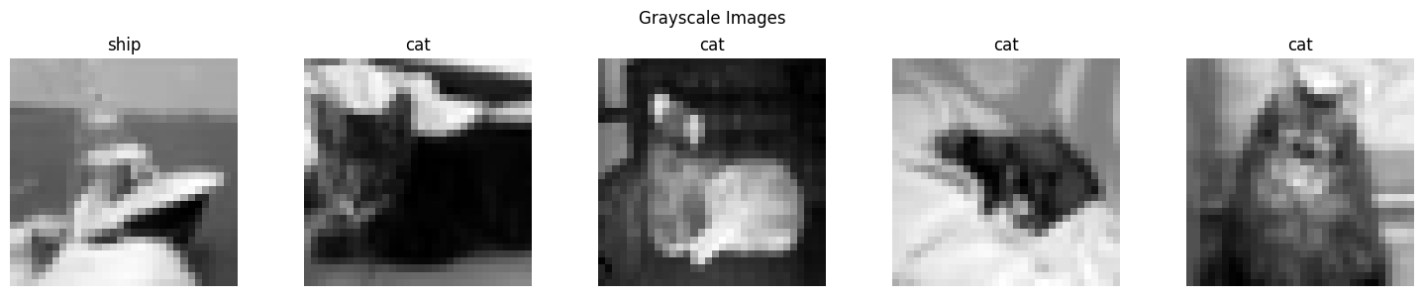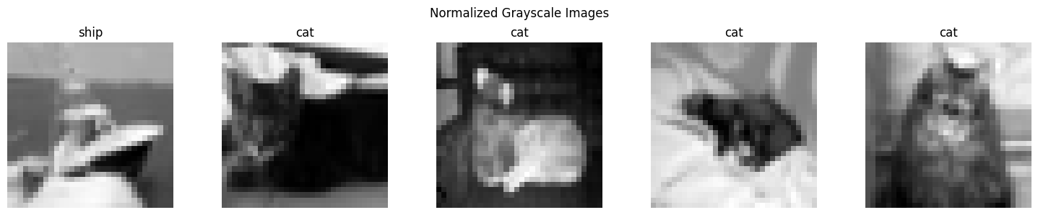

**Challenges Faced:**

One significant challenge was the computational intensity of training the SVM model on a large dataset. SVM can be slow with a considerable amount of data due to the quadratic complexity involved in the optimization process. To mitigate this, I utilized a smaller subset of the CIFAR-10 dataset for initial testing before scaling up to the entire dataset.

**Insights from Model Performance:**

The model's performance varied across different classes, with some classified with high accuracy while others showed notable misclassifications. The insights suggest that the images' complexity and inherent similarities (like color patterns or shapes) significantly impact the model's accuracy. The performance metrics highlighted areas for improvement, such as potentially using data augmentation techniques to enhance the training dataset.

**Question Responses:**

1. Why Install Libraries?

Installing libraries such as NumPy, matplotlib, and Scikit-learn is essential for image classification tasks as they provide data manipulation, visualization, and model-building tools. NumPy facilitates array handling, Matplotlib enables visual representations of data and results, and Scikit-learn offers various algorithms, including SVM, for machine learning.

2. What is a Support Vector Machine?

A Support Vector Machine (SVM) is a supervised machine learning algorithm that constructs a hyperplane in a high-dimensional space to classify data points. SVM efficiently divides the data by locating the hyperplane that maximizes the margin between various classes; this makes it very helpful for binary and multi-class classification tasks. Its ability to handle high-dimensional spaces makes it suitable for image classification applications.

3. What does **SVC(kernel='linear')** mean?

**SVC(kernel='linear')** indicates using a linear kernel in the Support Vector Classification (SVC) model. The linear kernel is a straightforward choice, meaning the model will attempt to find a linear hyperplane that best separates the classes in the data. This is suitable for datasets where the classes can be linearly separated.

**Critical Analysis**

Through this lab, I gained valuable insights into the applicability of SVM in image classification. While SVM performs well on smaller datasets, its efficiency decreases with larger datasets, where techniques such as kernel tricks or utilizing more sophisticated algorithms like Convolutional Neural Networks (CNNs) may be more effective. This reflection encourages a more profound exploration of hybrid models and advanced optimization methods for better performance in future projects.